Zenodo SOP-CEM

Purpose
This document establishes a standard operating protocol for creating a data repository for your published work using freely accessible database Zenodo.
As of January 1st, 2026, Federal Policy dictates that the data sets and the actual manuscripts for all federally funded research should be immediately available to the public upon publication. Furthermore, for long term preservation and long-term ease of use, this data should be consistent with FAIR (Findable, Accessible, Interoperable, and Reusable) principles. Briefly this means:
- To make data findable, data and supplementary materials should have sufficiently detailed descriptive metadata as well as a unique and persistent identifier such as a digital object identifier (DOI).
- To make data accessible, the metadata and data should be understandable to both humans and machines, and data should be stored in a trusted repository.
- To make data interoperable, metadata should use a formal, accessible, shared, and broadly applicable language for knowledge representation, such as agreed-upon controlled vocabularies. This means:
  - saving data as .txt and .csv files as opposed to Microsoft .docx or .xlsx files.
  - file names should clearly explain the data set
  - the top row of each column in .csv files clearly explains the column
  - A readme.txt file should be included in the repository that clearly describes each file. These will be explained below.
- To make data reusable, data and collections should have a clear usage license and provide accurate information. A Creative commons license is automatically generated.
It is CEM’s requirement that for every manuscript that you submit, you will need to create a data repository on a publicly accessible site, that at a minimum includes all the data (tabulated data, images etc…) that you used in the figures of your paper. Additionally, CEM recommends including raw unprocessed data with sufficient description of the processing procedure in the readme file, especially for extraordinary and high-impact publications.

CEM recommends Zenodo as a public data repository website. Visit Zenodo (www.zenodo.org)
Zenodo is a free-to-use EU Open Research Data Repository website that is committed to storing data sets forever. Each Zenodo Data Repository that you create can store up to 50 GB and 100 files of data.
Zenodo also has a protocol to allow you to keep your data private until your publication is accepted, allowing you to generate a link for anonymous reviewers to have access to your data set. Then, once your manuscript is accepted, you can publish your Zenodo repository, making it available to the public, which will generate a DOI number for your repository. This procedure is described in step 5 of the SOP.
Keep in mind that once your Zenodo data repository is “published”, the data cannot be changed. Only the metadata can be changed.

ZENODO Standard Operating Protocol
Go to the Zenodo Website, http://www.zenodo.org

Step 1. Create a Zenodo account.

You can sign up using your ORCID account and log in with it as well.
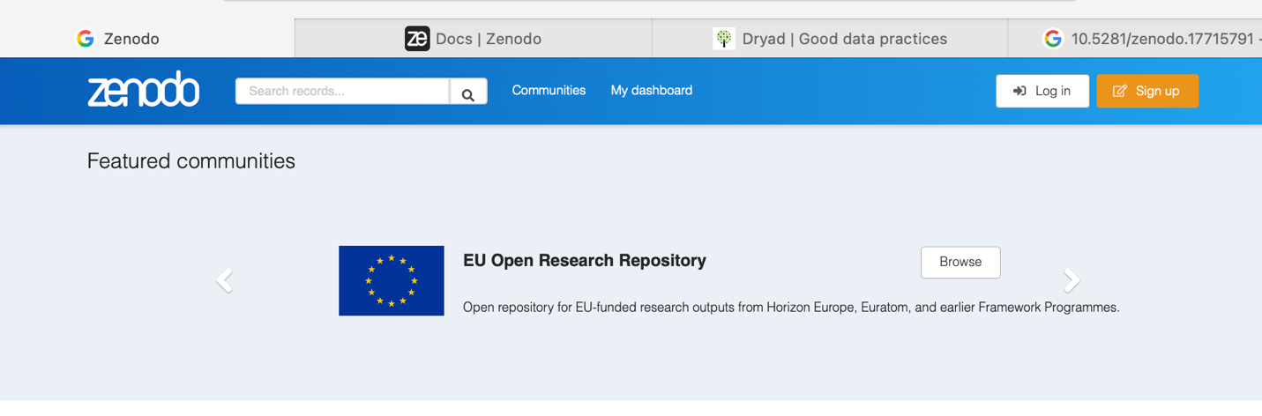

Step 2. Format your data sets so that they are compatible with FAIR principles
- Create a directory on your computer which you will use to store data sets and can compress into a single file later, if needed.

If you want to include both data sets and software in the same repository, separate them into clearly labeled folders.

Every data set used in a figure should be saved as a single file.

- To make a tabulated data set (such as excel, origin, igor, etc…) FAIR compatible, you must save it as a .csv or .tsv file. The first row must sufficiently explain the data in each column.

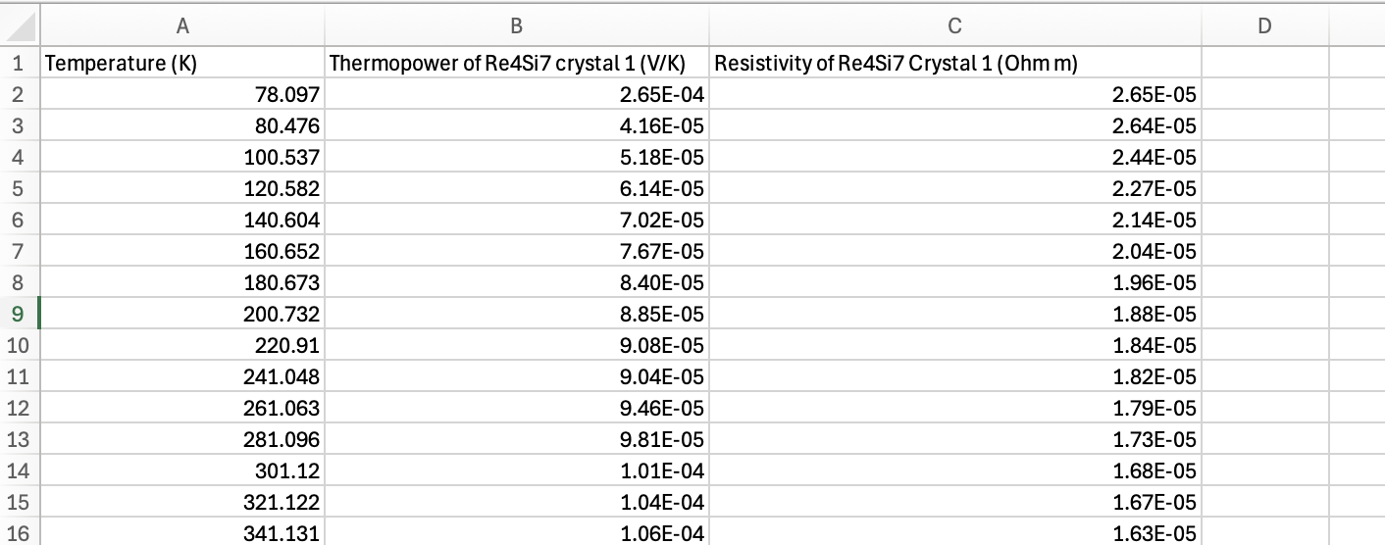
Example;

c. Name files and directories in a consistent and descriptive manner. Avoid blank spaces and special characters (‘ ‘!@#$%^&”) in filenames. Instead, use underscores or hyphens such as
The_quick_brown_fox_jumps_over_the_lazy_dog.txt
Additionally, use a common letter case pattern because they are easily read by both machines and people. For instance, the above .csv file has the following file name
1_Temperature_dependent_thermopower_and_resistivity_for_Re4Si7_crystal_1_along_in_plane_direction.csv
Here are a list of appropriate file formats:
- Text:
  - README files should be in .TXT, or .MD
  - Comma- or tab-separated values (. CSV, .TSV) for tabular data
  - Semi-structured plain text formats for non-tabular data (e.g., protein sequences)
  - Structured plain text (XML, JSON)
- Images: PDF, JPEG, PNG, TIFF, SVG
- Audio: FLAC, AIFF, WAV, MP3, OGG
- Video: AVI, MPEG, MP4
- Compressed file archive: ZIP
d. Include a readme.txt file that lists every data set file, and explains the contents.
- Description of file structure and contents
- Definitions of all variables, abbreviations, missing data codes, and units
- Links to other publicly accessible locations of the data
- Other sources, if any, that the data was derived from
- Any other details that may influence reuse or replication efforts.
Here is an example ‘readme.txt’

This Readme file was generated by Joshua Goldberger. (Goldberger.4@osu.edu)

General Information

1. Title: Dataset for ‘Title of Paper’

2. Author information
Oleksandr Molchanov
The Ohio State University

Ali Barooni
The Ohio State University

Joshua Goldberger
The Ohio State University

3. Arxiv: (put arxiv link here)

4. Description of the data

Enclosed you will find all of the data collected for the manuscript entitled, "Title of Submitted Manuscript". Magnetic Susceptibility data was collected using a Quantum Design Squid Magnetometer (MPMS3) at NanoSystems Laboratory at OSU. The Thermopower and Resistivity Data was collected using a homebuilt setup.

5. Abbreviations: No Abbreviations are used.

6. Folder and File Structure:

The files are combined in a single folder and numbered in the order that they appear in the manuscript as figures.

'1_Temperature_dependent_thermopower_and_resistivity_for_Re4Si7_crystal_1_along_cross_plane_direction.csv'
- Corresponds to the Measured Temperature dependent thermopower and resistivity along the cross-plane [1 0 1] crystallographic direction, shown in Figure 1a and 1b in the manuscript.
- Column 1 is the temperature (K), Column 2 is the measured thermopower (microVolts/K), Column 3 is the measured resistivity (ohm m)

'2_Temperature_dependent_thermopower_and_resistivity_for_Re4Si7_crystal_1_along_in_plane_direction.csv'
- Corresponds to the Measured Temperature dependent thermopower and resistivity along the cross-plane [7 0 -1] crystallographic direction, shown in Figure 1a and 1b in the manuscript.
- Column 1 is the temperature (K), Column 2 is the measured thermopower (microVolts/K), Column 3 is the measured resistivity (ohm m)

'3_Zero_Field_Cooled_Magnetic_susceptibility_of_Re4Si7'
- Corresponds to the Temperature Dependent Measured Magnetic Susceptibility of Re4Si7 for Zero-Field Measurements, shown in Figure 2a in the manuscript.
- Column 1 is the temperature (K), Column 2 is the Measurement Magnetic Field (Oe), Column 3 is the measured volume susceptibility (emu)

Step 3. Upload Data.
- Zenodo recommends that if you have less than 20 files, you can upload all files and the readme.txt file individually into the file tab. If you have more than 20 files, it is recommended you compress the files into a single .zip file and upload that instead.
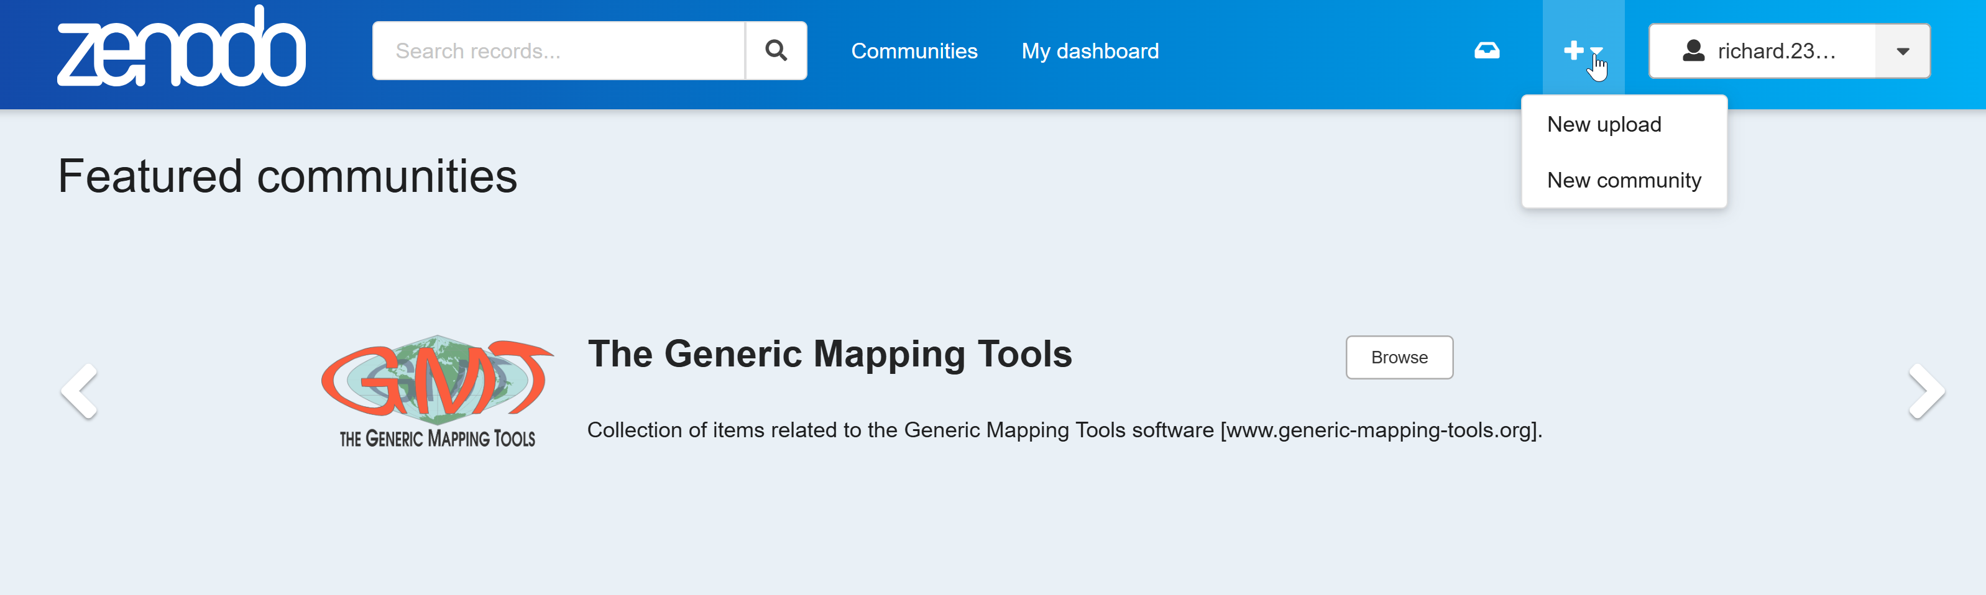
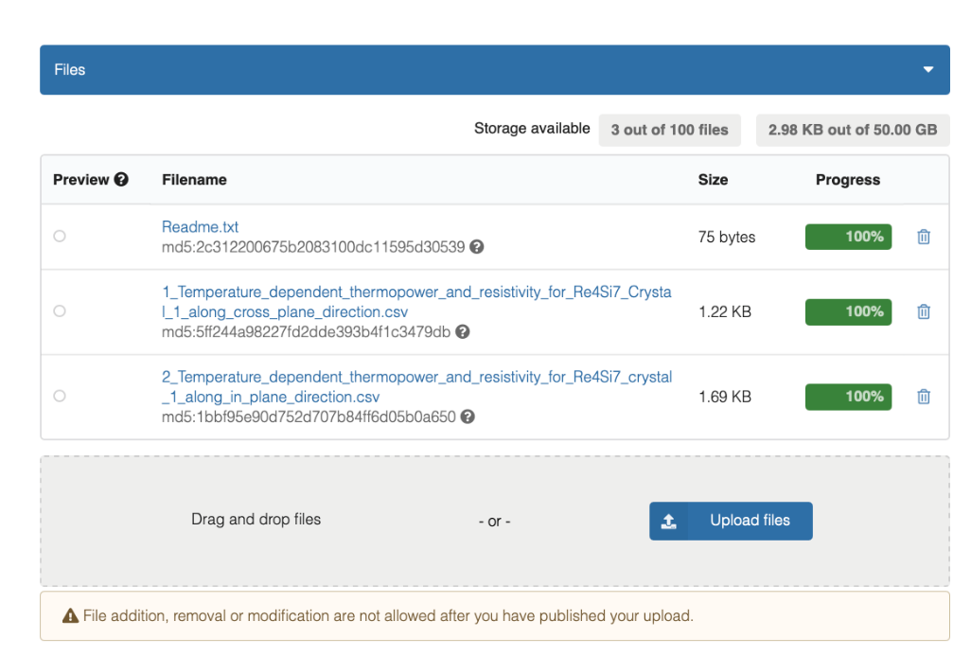
Example 1: Files uploaded individually

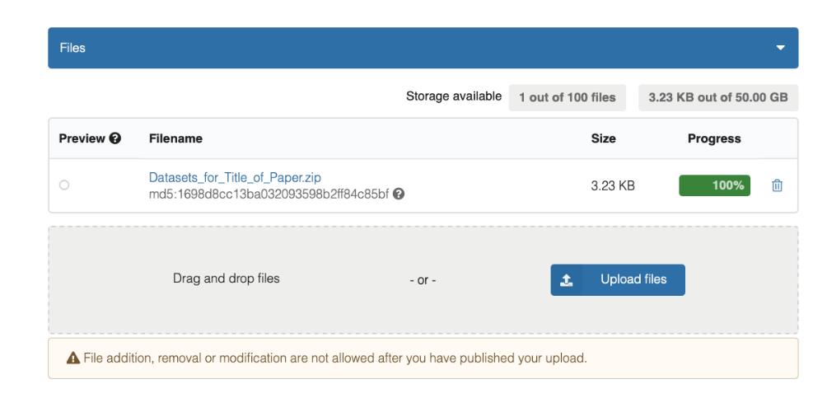
Example 2: A single zip file

Step 4: Fill out Metadata
  - Set Resource Type, to “Data set” and set Title to “Dataset for “The Title of Your Submitted Manuscript”
  - Add all manuscript co-authors as creators. Doublecheck that you have the correct ORCID ID for each co-author.
  - Fill out Description as shown below.
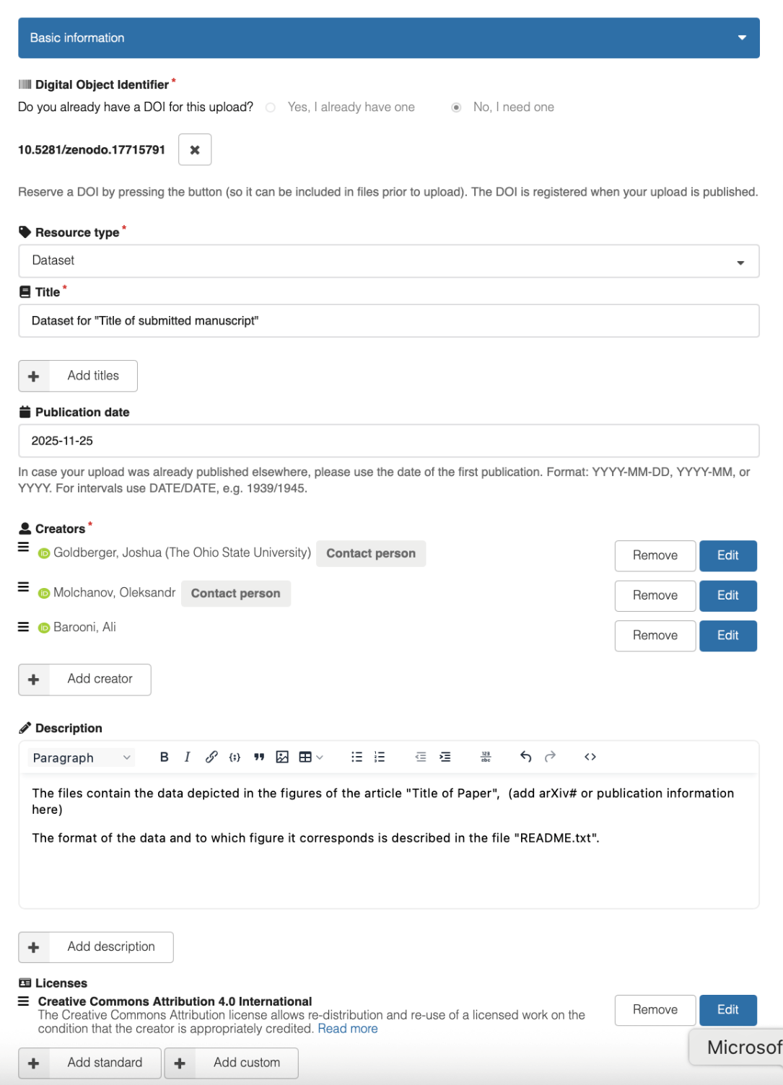
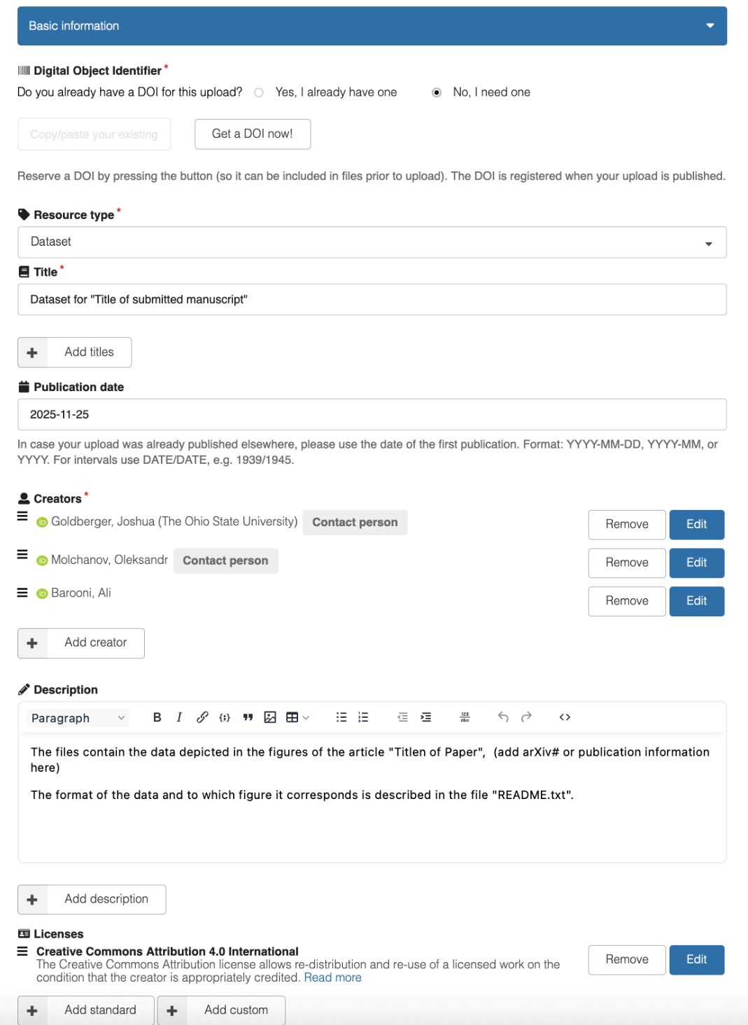

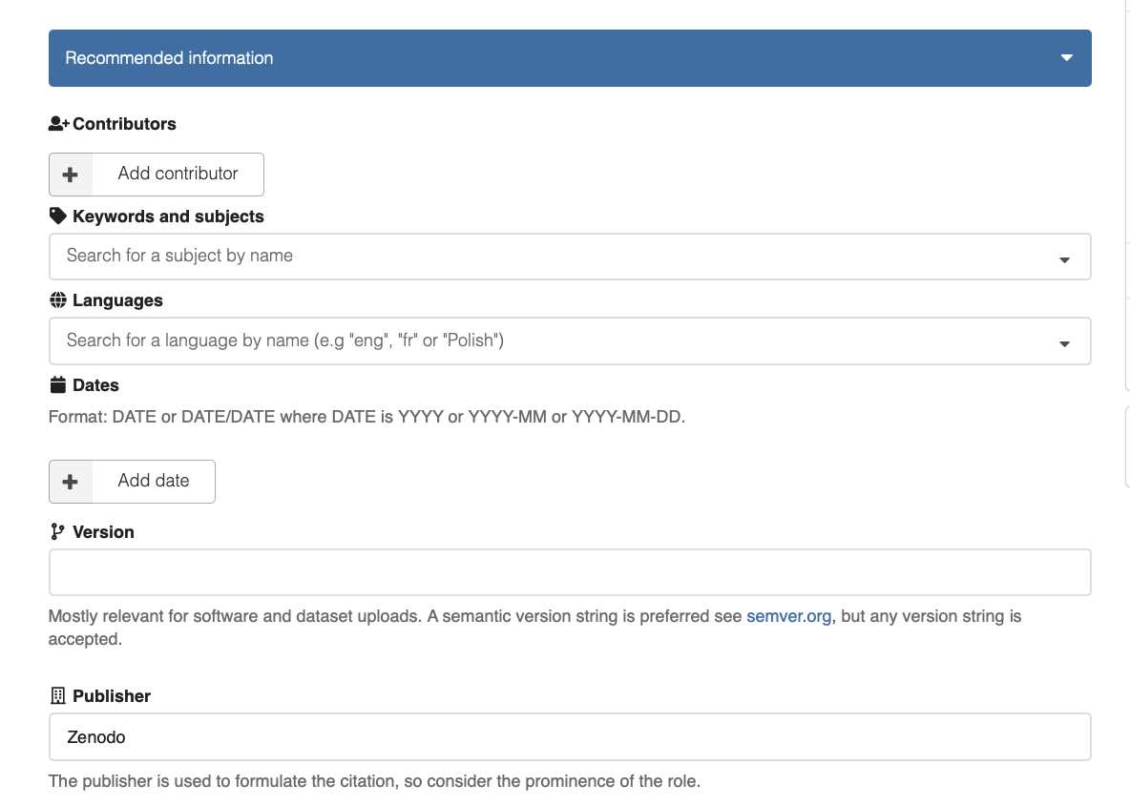
  - Recommended Information You can leave this blank.

  - Funding

Make sure you acknowledge the CEM grant!
Enter all funding information. For CEM 2020-2026, enter in “2011876”; Zenodo will automatically obtain the award information from the funding databases.
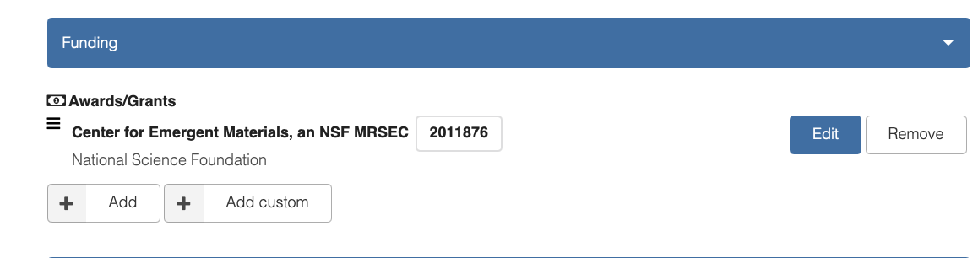

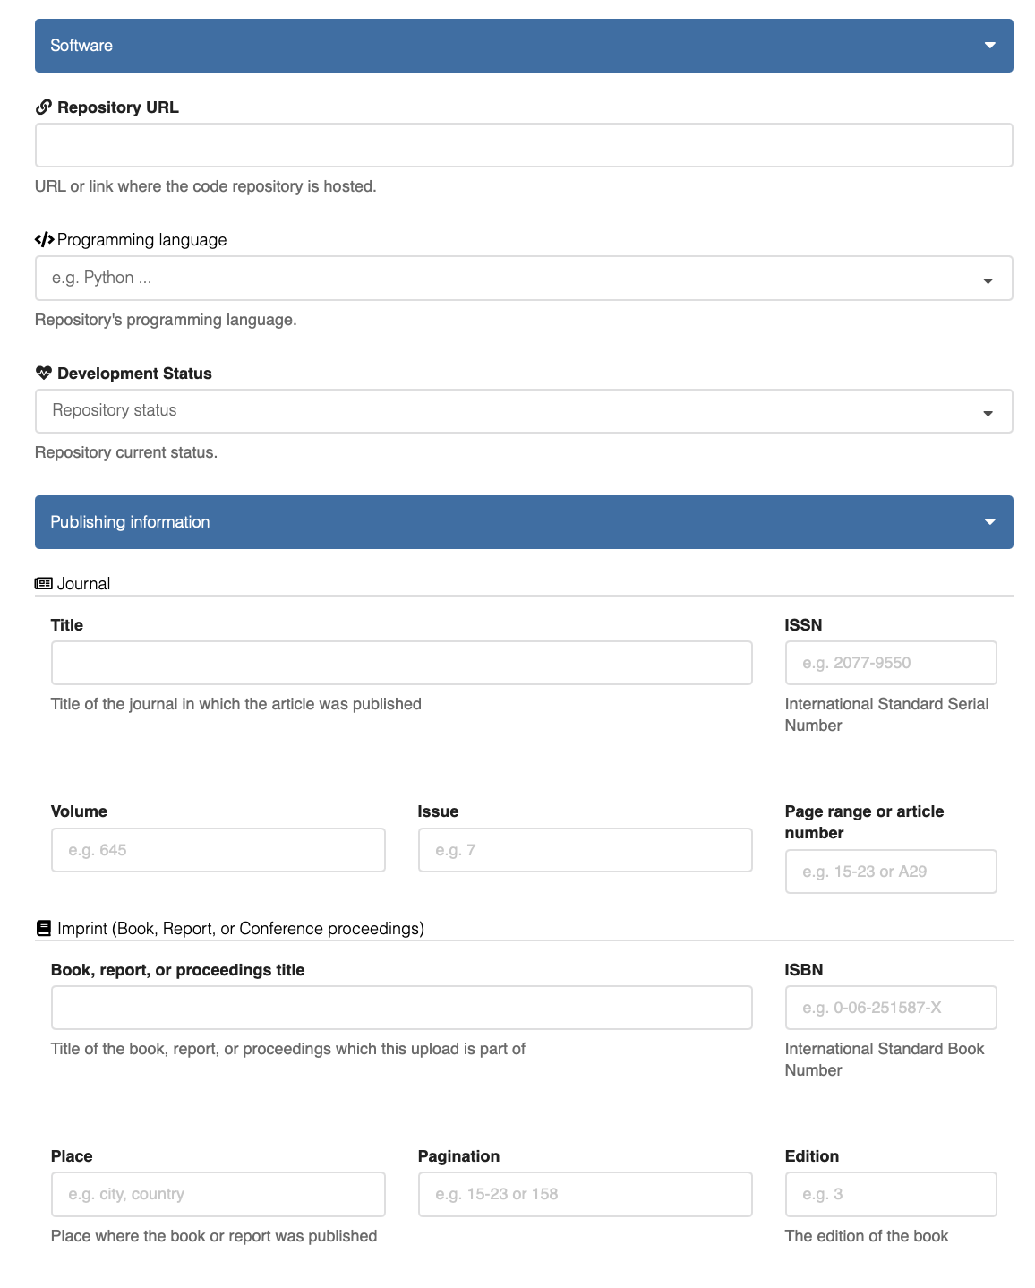
  - Software: Include Github Repository URL if applicable.

  - Publishing Information: Include published manuscript in metadata, once accepted.

Step 5. Sharing Data Set.
These menus are located on the right side of screen

- First, click “Save draft.”

- Then Click “Preview” Make sure that a preview appears, and there are no missing required metadata entries in the menus on the left side. Red asterisks/error will appear if you have missing required metadata. You can delete metadata requirements as these are unnecessary.

- Make sure the visibility is set to public.

- If you want to generate a link for the data set for reviewers without publicly sharing the data set, click “SHARE”. Do NOT click “PUBLISH”
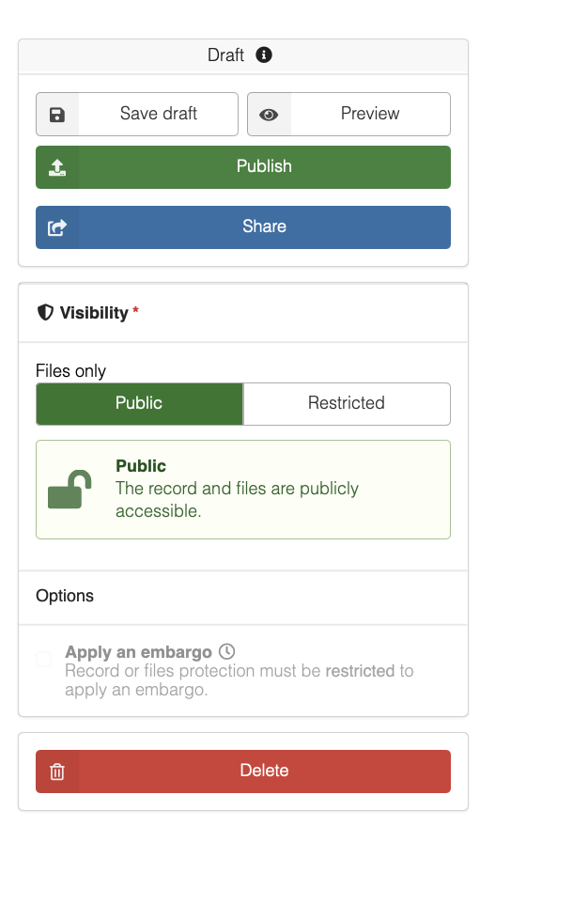

Zenodo publish and share menu showing options to save draft, preview, share, or publish a dataset.

- When you click on Share, click on the “Links” tab.
Then at the bottom create a “Short name for your link”
Make sure users “Can preview drafts”
Then click “Create a new link.”

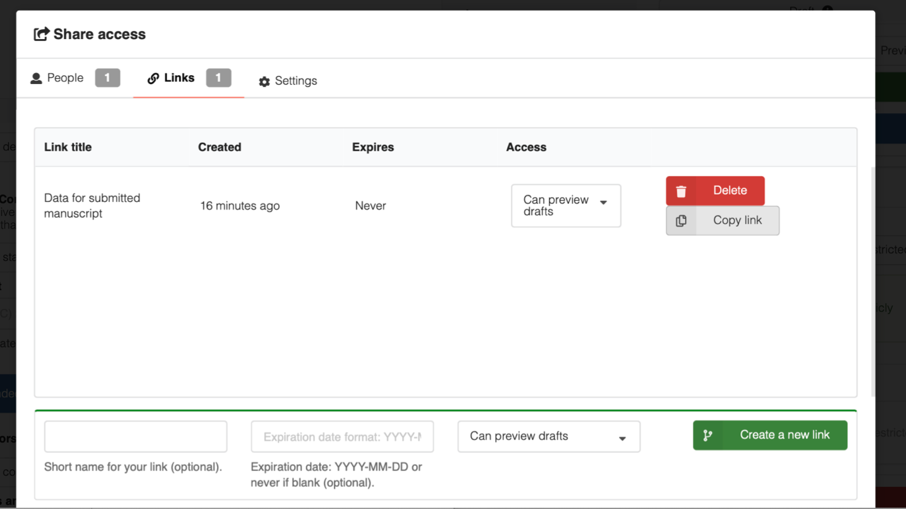
You can then “Copy link” and paste the link into your submitted manuscript.

- Once the manuscript is accepted (or you feel comfortable sharing the data beforehand)
Click “Publish” Once the data set is published, you cannot modify the data. You can change the metadata only.

Step 6: Accepted Manuscript!
- The day your paper is accepted and receives a DOI;
  - Publish your Zenodo database (see previous step) which will generate a DOI
  - Email the DOI of the manuscript, and the DOI of the Zenodo database to both Rachel Page and Josh Goldberger. We will enter this information into the NSF PAR (Publicly Available Repository) to ensure it is immediately accessible.

  - The Zenodo DOI is in the Basic Information Menu on the left side.
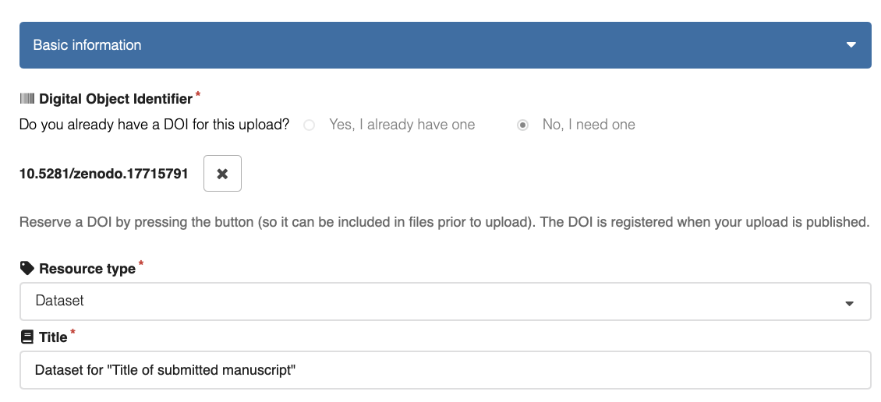

If you need help or more information, see the Zenodo help guides at https://help.zenodo.org/docs/
Or contact, Josh, IAC members or other CEM members with Zenodo expertise.

